Life Cycle Assessment of Several Types of Tropical Timber Used for Pile Planking
Executive Summary

Introduction
Pile planking is a major market for sustainably produced tropical timber. However, despite its positive and eco-friendly properties, timber is facing stiff and increasing competition from steel and plastic (both virgin and recycled). This prompted an official study into environmental ratings for timber pile planking made from the three most commonly used and sustainably produced tropical hardwoods. A separate exploratory study was also conducted to compare environmental ratings for timber pile planking with those for steel and plastic (virgin and recycled) sheet piling.

A Life Cycle Assessment (LCA) is currently the best and most widely accepted method for assessing environmental impact, despite several limitations in relation to assessing timber originating from sustainably managed forests.

Initiative & Responsibility
Koninklijke VVNH and FSC Nederland took the initiative to perform a life cycle assessment of several types of tropical timber used for pile planking. The project was financed by the European Sustainable Tropical Timber Coalition (EUSTTC), which also seeks to increase market share for sustainably produced timber. Koninklijke VVNH led the project with the support of a supervisory committee made up of representatives from the timber trade and building industry. The LCA was performed by Ernst & Young Climate Change & Sustainability Services (EY CaS) and independently verified by the LCA department at Stichting Houtresearch (SHR).

Purpose
The aim of the LCA was to: (1) gain a better insight into environmental ratings for pile planking made from the foremost types of tropical timber, (2) make up-to-date environmental information available for inclusion in the Nationale Milieudatabase (NMD) [National Environmental Database] and other international life cycle inventory databases such as EcoInvent, (3) promote the use of tropical hardwoods from sustainably managed forests by publishing and publicizing their environmental profiles, and (4) to identify any negative environmental impact issues for any of the materials in question.

Timber Pile Planking Specifications
The piling used for this LCA was made from 5 m long, 50 mm thick, tongue-and-groove planks supplied in varying widths and with timber waling (150 × 100 mm) secured by a steel nut and bolt, as commonly used in practical situations (Geobest, 2015). The types of timber used as references were azobé, okan and red angelim.

Method
This LCA satisfies the criteria specified in various national and international standards for performing life cycle assessments, as well as related environmental product declarations (EPDs) – NEN-EN 15804, NEN-ISO 14040, NEN-ISO 14044, NEN-ISO 14025 and Assessment Method: Environmental Performance for Construction & Civil Engineering Works (Stichting Bouwkwaliteit (SBK)).

Data Sources & Assumptions
Data about timber pile planking throughout its life cycle was obtained from various VVNH-affiliated timber yards, civil engineering contractors and clients. Field data relating to the countries of origin (logging, processing and transportation) was obtained from the leading suppliers of the types of timber being assessed. EcoInvent process data was also used. Where timber is transported by sea, it was assumed that 'slow steaming' practices had been adopted. A lifespan of thirty years was assumed as a reference, based on SBR publications about lifespan, practical experience and client criteria. The re-usability percentage for timber pile planking was set at 25%. The basic unit used for assessment purposes was a cubic metre (m³).

Environmental Impact
The charts below depict sustainability ratings for pile planking made from each type of timber and expressed as an Environmental Cost Indicator (ECI). Fig. 1 depicts the ECI score for each type of negative environmental impact.
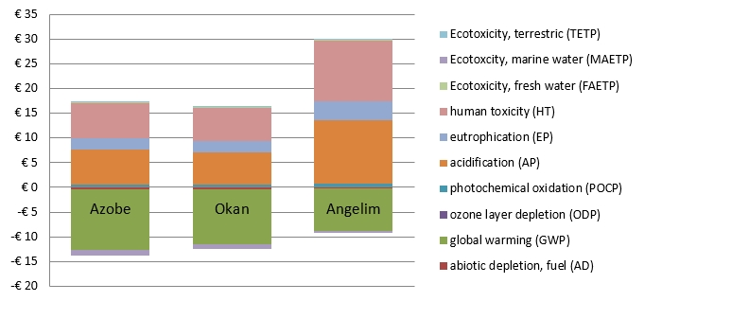
Fig. 1: ECI score summary for 1 m³ of azobé, okan and red angelim pile planking with lifespan of 30 years for selected structural scenario
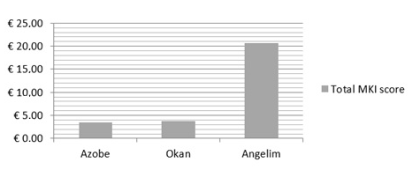
Fig. 2: Total ECI score for 1 m³ of azobé, okan and red angelim pile planking with lifespan of 30 years for selected structural scenario
Conclusions
Transporting pile planking to the Netherlands contributes the most towards azobé and okan's ECI scores in relative terms, and the most to red angelim's in absolute terms. Constructing and dismantling pile planking structures also contribute a significant portion. Energy and heat recovery, however, make a large positive contribution (credits) in terms of eco-friendliness. The data for the environmental profiles illustrated will be incorporated into the NMD. The total ECI score is shown in Fig. 2.

Sensitivity analyses revealed that the variables that have the greatest effect are: (1) recycled percentage, (2) slow steaming, (3) distance to supplier, and (4) method for attributing utilization of non-reusable pile planking parts for energy recovery purposes and by resellers during waste phase.

This LCA was based on the current energy mix in the Netherlands, which may be changed to a less fossil-fuel based composition in the waste phase, meaning that timber products would receive fewer credits.

Recommendations
The foremost recommendation entails minimizing the negative environmental impact caused by transportation. This could be achieved by changing fuel types, modes of transport, distances, etc. This could even result in additional credits for timber, as energy can be recovered during incineration that replaces the use of coal, oil and gas. If transportation-related measures cannot be adequately addressed, it is recommended that pile planking lifespan be prolonged and reusage be increased.

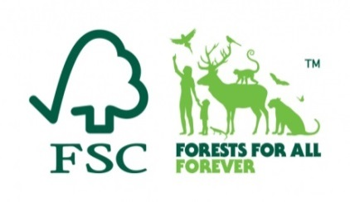
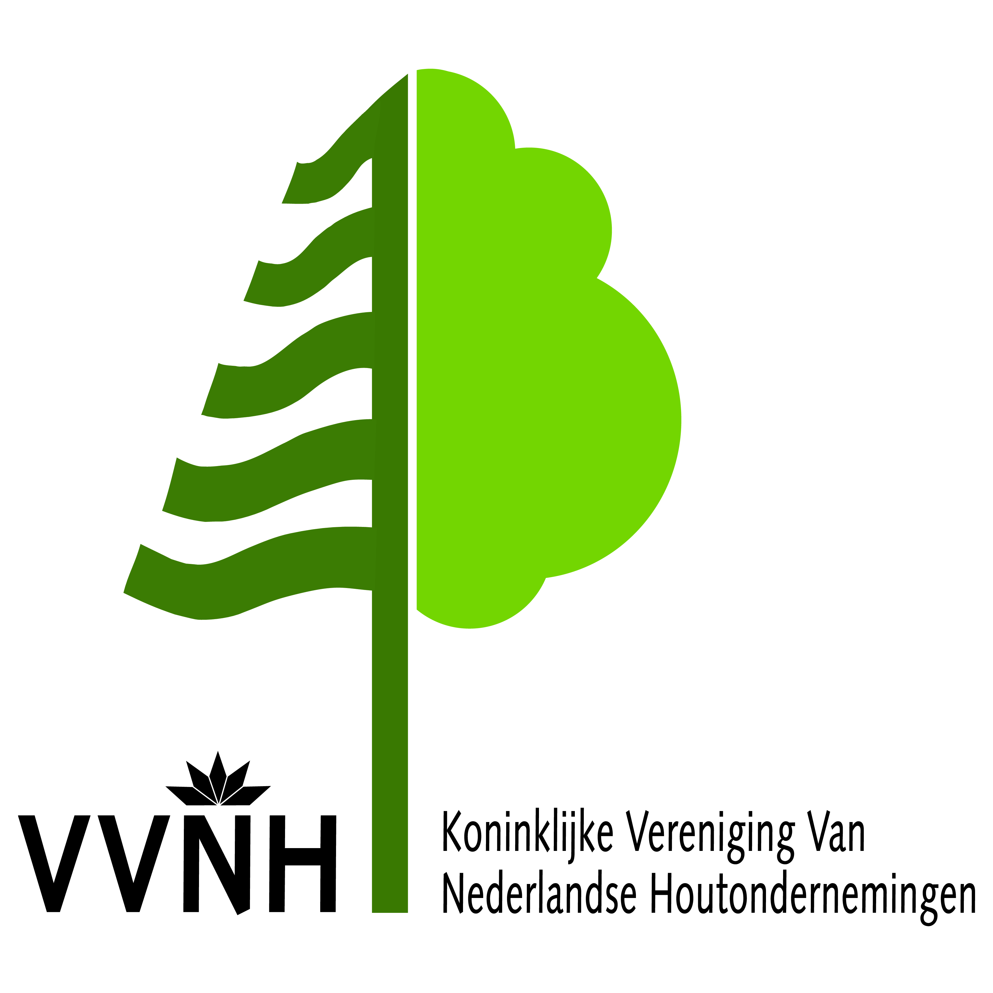
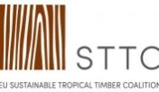
Exploratory Life Cycle Assessment – Comparison of Timber, Steel and Plastic Sheet Piling
Executive Summary
Introduction
Pile planking is a major market for sustainably produced tropical timber. However, despite its positive and eco-friendly properties, timber is facing stiff and increasing competition from steel and plastic (both virgin and recycled). This prompted an official study into environmental ratings for timber pile planking made from the three most commonly used and sustainably produced tropical hardwoods. A separate exploratory study was also conducted to compare environmental ratings for timber pile planking with those for steel and plastic (virgin and recycled) sheet piling. The data on timber was obtained from the study titled Life Cycle Assessment of Several Types of Tropical Timber Used for Pile Planking (February 2016).

Steel & Plastic Pile Planking Specifications
The following reference cross-sections (see table) have been selected for steel and plastic sheet piling based on a geotechnical analysis performed by Geobest - these, for reference purposes, being technically equivalent to the timber pile cross-sections used: steel: cold-rolled PW3030 and plastic: GW 460/5.5 Omega. Two compositions were assessed for plastic sheet piling: (1) 100% virgin, and (2)
100% recycled

Method
The environmental impact for steel and plastic sheet piling was determined in exactly the same way as for timber, complying with Stichting Bouwkwaliteit (SBK) criteria. Publicly available data was used. For practical reasons, it has been decided to designate this LCA comparing timber, steel and plastic as 'exploratory' rather than 'comparative', as basis for a possible more extensive study.

Purpose
The aim of the LCA was to: (1) compare environmental ratings for timber, steel and plastic sheet piling, and (2) assess the need for a more extensive and independently verified study.

Lifespan, Functional Units & Life Cycle Phases
The lifespan for steel is one hundred years and for timber and plastic thirty years. The functional unit was set at 1 m² of sheet piling. Calculations were based on a lifespan of thirty years. 1 m² of timber pile planking equates to 0.054 m³ of tropical hardwood (azobé). The following were taken into account for timber, steel and plastic: raw material extraction,transportation to production,site pile planking production,transportation to construction site, sheet piling construction, and recycling/disposal.

Environmental Ratings for Various Sheet Piling Materials (Exploratory)
Impact Category | Unit | Total | Production  (A1/A2/A3/A5) | Transportation to  Construction Site (A4) | Transportation to  Waste Processing Site (C2) | Waste Processing  (C1/C3/C4)
Azobé | €/m² | 0.19 | 0.51 | 1.22 | 0.13 | -1.67
Red Angelim | €/m² | 1.12 | 0.69 | 2.01 | 0.14 | -1.73
Okan | €/m² | 0.20 | 0.49 | 1.11 | 0.11 | -1.51
Steel | €/m² | 26.64 | 26.35 | 0.20 | 0.04 | 0.05
PVC (100% recycled) | €/m² | 4.19 | 2.73 | 0.32 | 0.02 | 1.11
PVC (100% virgin) | €/m² | 4.79 | 3.34 | 0.32 | 0.02 | 1.11
Table 1: ECI score (€/m² of sheet piling) – exploratory assessment of various sheet piling materials over lifespan of 30 years for scenario selected
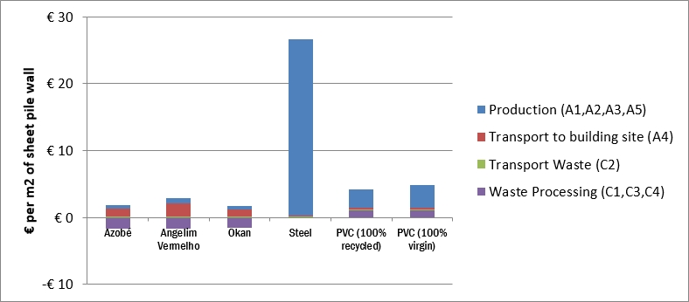
Fig. 1: Single Score (€/m² of sheet piling) – exploratory assessment of various sheet piling materials over lifespan of 30 years for scenario selected
Conclusions
Steel sheet piling has by far the greatest negative environmental impact of all the materials assessed. Although both plastic variants scored a lot lower than steel, timber still came out best in terms of overall environmental impact. This LCA therefore concludes that timber pile planking would appear to have the least negative environmental impact.

Recommendations
Given the results, it is recommended that a more extensive and third-party verified LCA be performed in order to officially endorse timber pile planking's environmental benefits.

